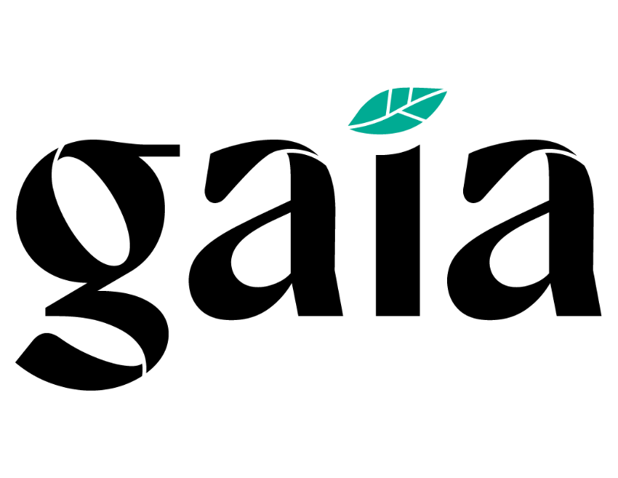

Gaia

Data Synchronization Implementation Guide

Version 1.0

Data Synchronization Implementation Guide

Table Of Contents

GAIA SYNCHRONIZATION INFORMATION.…………………………….4
  - Primary Data Synchronization Contact 4
  - Gaia GLN - Publish To…………………………………………………. 4
- STEPS TO BEGIN SYNCING YOUR DATA WITH GAIA……………..5
  - Implementation Steps: 5
  - Publication Steps 5
  - Catalog Item Confirmations (CICs)……………………………….6
- ATTRIBUTE REQUIREMENTS 7

Revision History

Date | Version # | Description of Change | Author
1/24/2024 | 1 | Initial document | J. Lott

GAIA SYNCHRONIZATION INFORMATION

Primary Data Synchronization Contact
Primary Data Synchronization Contact Email: datasync@gaiak12.com

Gaia GLN - Publish To
Production: 1200144058434

STEPS TO BEGIN SYNCING YOUR DATA WITH GAIA

Implementation Steps:
- Fill out the Trading Partner Form on the Gaia Landing Page:
https://1worldsync.com/trading-partners/gaia/
- Have your accurate item data loaded into your home data pool and ensure it is ready for publication.

    - Contact your GDSN data pool provider for any education you might need to complete this step.
    - Ensure you are providing the necessary data attributes requested by Gaia as outlined in Section 3 of this document.
    - Have your complete and accurate item data loaded into your GDSN-certified data pool and ensure it is ready for publication in Production.
    - Gaia will create a subscription based on Manufacturer’s GLN.

Publication Steps
- Gaia requests their suppliers to publish ALL items that are suitable for school kids in K-12 and originated in the United States to Gaia GLN 1200144058434.
- Publish all items with a Publication Type of “New” for all new publications. Republish as “Initial Load” for items previously published to the Gaia GLN.
- Investigate and respond to “REVIEW” CIC responses. Gaia will provide feedback on publications using the following methods.

***The specific focus should be the inclusion of the following information:

    - Child Nutrition Labels
    - Ingredient Lists
    - Nutrient Labels
    - Formulation Statements

Data Synchronization Implementation Guide

Catalog Item Confirmations (CIC’s)
Gaia will automatically return a CIC message to the supplier of “Received”. However, the following CICs sent will be based upon the following:
CIC Messages:
RECEIVED: (Auto Generated): Items have been received, but Gaia has NOT made any GDSN validations. This response will typically be sent once publication for a specific document has been completed.
REVIEW: The item does not pass Gaia GDSN validations or item has failed the audit process and therefore has data discrepancies to be reviewed and addressed. Gaia will provide a reason as to why a specific item hierarchy is in this state for the applicable attribution.
SYNCHRONIZED: The item has been fully accepted and loaded into Gaia’s internal system and will be updated as modifications and corrections occur. This response will be sent after all validations and audits have been completed.
REJECTED: Gaia no longer wants to receive publications or updates for this item to their internal back-end system or the item has been discontinued by the manufacturer or de-listed by Gaia.

Data Synchronization Implementation Guide

ATTRIBUTE REQUIREMENTS
The attribute guide can be found on the Gaia Landing Page:
https://1worldsync.com/trading-partners/gaia/
Please review the Gaia Attribute Guide for:
- Mandatory attributes by GDSN and 1WorldSync to ensure quality and completeness.
- Gaia specific conditional and optional attributes.

